Graduate assessment

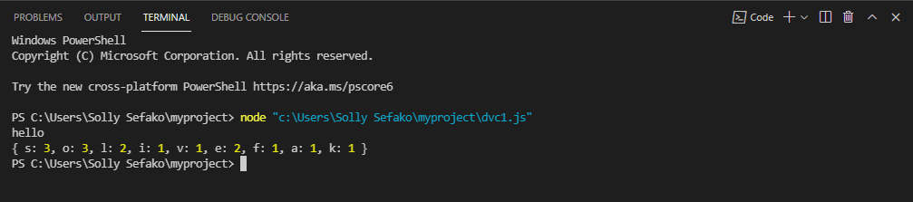

This is output for dvc1, it displays frequency of each character.

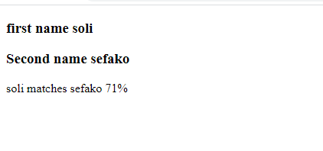

I used html, CSS, and JavaScript to come up with this out. The program finds match percentage using random method.

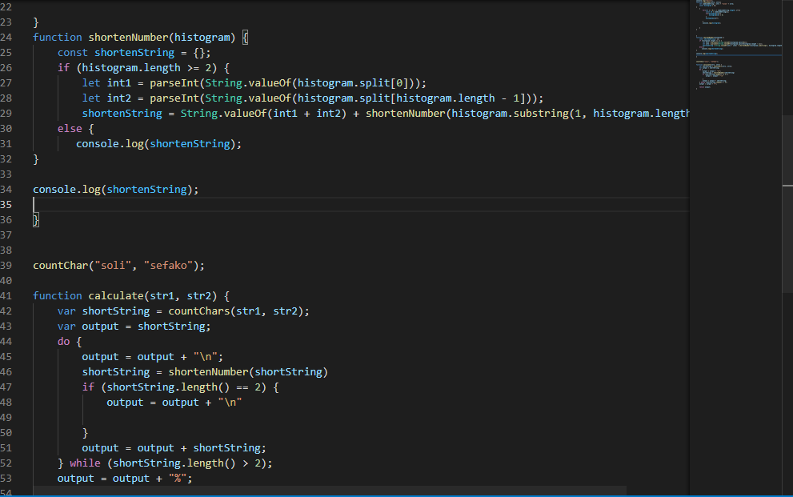

I was battling with this program, dvc1, to come up with a match percentage but I could not. I made function that shorten the numbers by adding first number with last number, second number with second last and so on. Unfortunately, I could not get it right, but I believe I was close.

**NB! This was my first-time coding in JavaScript, and this is how far I came, it was challenging task, but I had fun and learnt a lot as it has sparked my curiosity. I would be grateful to be considered for this graduate program so that I get opportunity to learn more and become better in the language.**

**P.S!**